Menstruation/period myths?

Which of the following statements are true or false?

After the first period, females always have their period every 28 days. | TRUE | FALSE | UNSURE
Not having a period some months is common amongst teenage girls.

Poor nutrition affects the length of time between periods.

The blood that comes out of the vagina during a period is the lining of the uterus.

Stress can affect the length of time between periods.

Females always get cramps during their periods.

All females menstruate by the time they are 15.

When a female starts menstruating it means she could get pregnant if she has unprotected sexual intercourse.

When a female is menstruating she can not exercise (including swimming) until it is over.

The statements below describe the different stages of the menstrual cycle. Match up the correct statement to the correct stage in the menstrual cycle in days.
· days 1-7
· days 8-13
· day 14
· days15-28

 | Egg maturation  The egg cell starts to mature  in the ovary.  The uterus lining builds up |  | Most fertile time  The egg cell is swept along the  oviduct towards the uterus
 | Menstruation (period)  The lining of the uterus  breaks apart and passes out of  the vagina, with blood |  | Ovulation  The egg cell is released from the  ovary

Then answer the following questions: -

- What happens to the menstrual cycle if an egg cell is fertilised between day 15 and 28?

- What does fertile mean?

- If a woman was to have her period, starting 6th November, when would be the next likely date that she would have her period?

Menstrual Cycle

1. (a) Give the full name of the female hormone below:
i. FSH
ii. LH
iii. GnRH

(b) Which one of these hormones is is secreted by the hypothalamus?

(c) What is its target organ?

2. The diagram below shows the development of a follicle during the menstrual cycle.

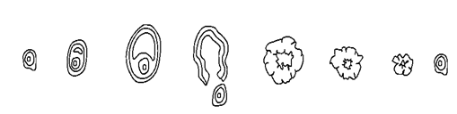
Place the letter to the diagrams above that corresponds to the following descriptions.

(a) Has recently been affected by LH
(b) Is affected by FSH
(c) Is degenerating
(d) Is filled with fluid
(e) Secretes most oestrogen
(f) Secretes most progesterone

3. These graphs show typical hormonal changes for a woman in her late 20s.

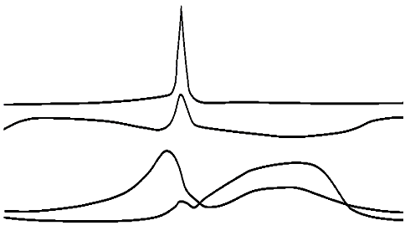

(a) Oestrogen has different effects depending on its concentration.

(i) Put a S on the graph whenever oestrogen stimulates LH secretion.

(ii) Put an I at a point where oestrogen inhibits LH secretion.

(b) FSH causes new follicles to develop.

Put a F whenever FSH is acting on a new follicle.

(c) Menstruation begins when the progesterone level falls.

Put a M whenever menstruation begins.

The Story of the Menstrual Cycle

Read the following story. Each time there is a choice, check off the one that is true.

Once upon a time, there was a female reproductive system. Each month, the
Uterus/ vagina
invited a thick, soft lining t grow along its walls, which was made up of tissue and blood that contained the nutrients that would be needed t nourish a fertilized
ovary. / ovum.
Once the lining had grown, it waited for the ovaries t d their job. You see, the ovaries contained special reproductive cells, each called an
ovum. / cervix.
Each month, one of the reproductive cells would reach maturity and be released from the
ovaries./ fallopian tubes.
This month, it was the right one that got t release a reproductive cell. The left one would have t wait until the next month. After the reproductive cell is released it went toward the
ovaries / fallopian tubes
which waved their numerous arms, grabbed the reproductive cell that was just released and gently guided it int one of the tubes. The reproductive cell traveled slowly down the tube. After about a day of travel, it began t dissolve. When it had disappeared, the brain sent a message t the
ovum/ lining
telling it that a fertilization didn’t occur, s it could leave the uterus. Slowly, it passed through the
vagina,/ cervix,
then the
vagina,/ cervix,
and out of the female’s body. As soon as the lining was gone, the uterus invited a new lining t start t grow. This time around, it would be the left
ovary/ uterus
and the left
vagina/ fallopian tube
that would do all the work. Then, the process would start all over again. This process is called menstruation. The End

Hormones and the Menstrual Cycle

This diagram shows what happens in the menstrual cycle:
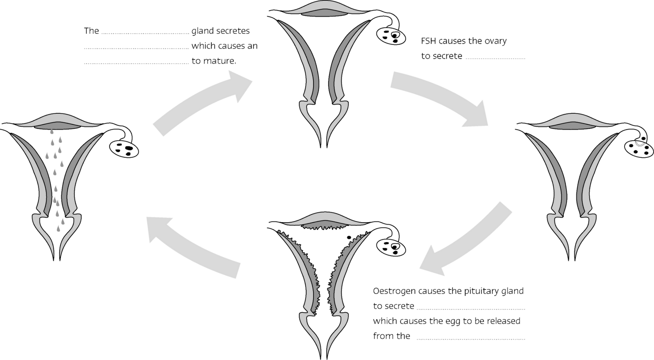
Fill in the spaces using some or all of these words:
FSH LH testis ovary oestrogen
egg sperm uterus pituitary

Quiz 1

The graph shows the levels of two hormones involved in the menstrual cycle over a two month period. Examine the graph carefully and answer the questions below.
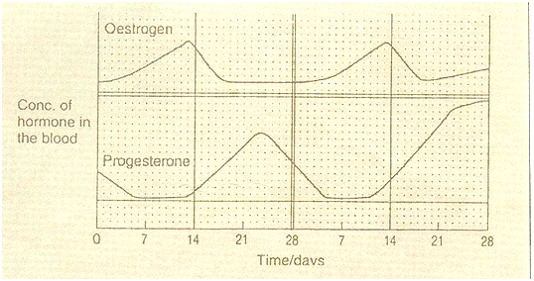
GRAPH SHOWING THE CONCENTRATION OF TWO SEX HORMONES IN THE BLOOD OF AN INDIVIDUAL WITH A REGULAR 28-DAY MENSTRUAL CYCLE

Describe briefly the changes which would be taking place in the ovary and the uterus between days 5 and 17 of the menstrual cycle. (7 marks)
Shade TWO periods on the graph during which menstruation really takes place. (2 marks)
State ONE day of the cycle on which sexual intercourse could lead to pregnancy. Give ONE reason for your answer.(2 marks)
How are the levels of the two hormones at day 28 of the first cycle different from the levels at day 28 of the second cycle? Give ONE explanation for the difference you describe. (6 marks)
Quiz 2

1. ‘Menarche’ is the medical term used to describe a girl’s first menstrual cycle. What is the average age at which a girl will have her first period?
a. 14
b. 12
c. 16
d. 11

2. The length of an average menstrual cycle is 28 days, however a ‘normal’ cycle can range anywhere from 28- 35 days in length, depending on the woman. What part of the cycle is counted as day one?
a. First day of menstrual bleeding
b. Day of ovulation
c. Last day of menstrual bleeding
d. Day before a period starts

3. Which of the following hormones is necessary in the production of a normal menstrual cycle?
a. Estrogen
b. Follicle Stimulating Hormone (FSH)
c. Progesterone
d. All of the above

4. Which of the following would indicate a trip to your physician was in order?
a. If you have not started menstruating by age 16
b. If you suddenly stop having periods and is not pregnant
c. All of these
d. If you bleed between periods (more than a drop or two)

5. Not all women have normal, predictable menstrual cycles. Many women encounter heavy bleeding. Some deal with intense pain. Others may stop having or skip periods. What condition does the term dysmenorrhea refer to?
a. Very heavy menstrual flow
b. Excessively painful periods
c. Absence of menstrual flow
d. Irregular cycles

6. After the egg (ovum) is released during ovulation, it makes it way, via the fallopian tube to the uterus. What happens to an unfertilized egg?

a. It is dissolved or absorbed into the body
b. It re- attaches itself to the ovary
c. It migrates back to the fallopian tube
d. It stays in the fallopian tube

7. A woman is most likely to get pregnant when?
a. They have taken a contraceptive pill
b. They have reached the age of 35
c. It is day 14 of the menstrual cycle
d. It is Carnival time

8. The hormone oestrogen is produced in the?
a. Ovaries blood stream
b. Pituitary gland
c. Testes
d. Bloodstream

9. LH is responsible for?
a. Inhibiting FSH production
b. Building up the lining of the uterus
c. Causing the release of an egg (ovulation)
d. Causing an egg to mature in the ovary

10. Do menstruation and menstrual cycle mean the same thing?
a. Yes
b. No

(a) What is the menstrual cycle and how is it controlled? (8 marks)
(b) Suggest what might happen if,
(i) The corpus luteum failed to develop after fertilization
(ii) A nine-year-old girl had to have her ovaries removed.
(4 marks)

